Young Li

A13750891

Ying (Patrick) Pei

A13595990

Lab: (Monday 7-10PM A55)

Lab Room: WLH-2215

ECE 35 Lab 3 Report

**Introduction**

This lab is designed to help students understand, design and build an analog optical data link. The optical links are light emission and detection that can pass analog or digital signals, but most are optimized for digital signals with low interference through free space and with excellent rate of data transfer. Optical links are used for long distance communications via fiber lines but they are also commonly used for a wide variety of short distance applications such as the fiber-channel disc interfaces within hard drives and simple TV infrared (IR) remote controls. The circuit will make use of an operational amplifier as well as photonic devices such as LED and photodiodes. In this lab we will be created a voltage controlled current source to drive the LED linearly.

**Procedures**

**Prelab Part**

* For the pre lab we are told to solve the circuit that is provided in the instructions
* We have to find Av and analyze the input and output voltages.
* We first check the values when it is ± 1 V and then check ± 3 V.
* We plot the data and make a graph for what it should look like as a triangle function.

**Lab Part**

* First, we build the prelab circuit and verify what we solved for was correct.
* We are required to analyze the circuit and to see if it matches what we solved for in the prelab
* There are two diagrams further down in the lab instructions.
* We have to build one circuit, and power the other one with the first circuit we built.
* This was done by connecting the first circuit to the function generator.
* The first circuit powered an LED light which began to produce light.
* Then the LED part was emitting light and we have to use a light detector (photodetector) to power the other circuit.
* The second circuit starts running off of the light emitted from the LED part.
* We have to connect our circuit to the O-scope and analyze the sine function.
* Afterwards, we are to install a capacitor in parallel with the 1M resistor to reduce the weird disturbance in the frequency.
* The curve should look smoother after the capacitor is in place.
* To see it easier, we were told to put it in a square function.

**Clean Up**

* Put everything away and clean up lab station.

**Circuit Diagrams and Pictures**

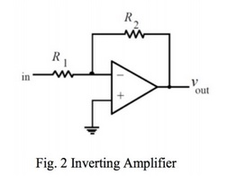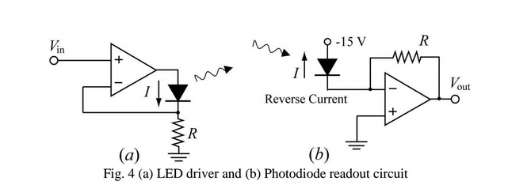

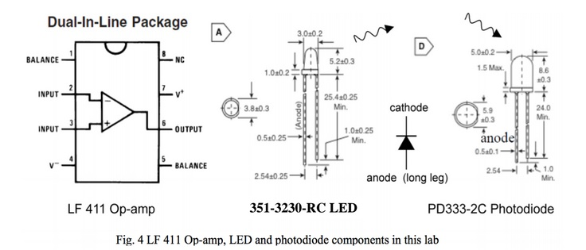

**Data Collected**

These two pictures above illustrate the Pk to Pk voltage for 1V and 3V respectively.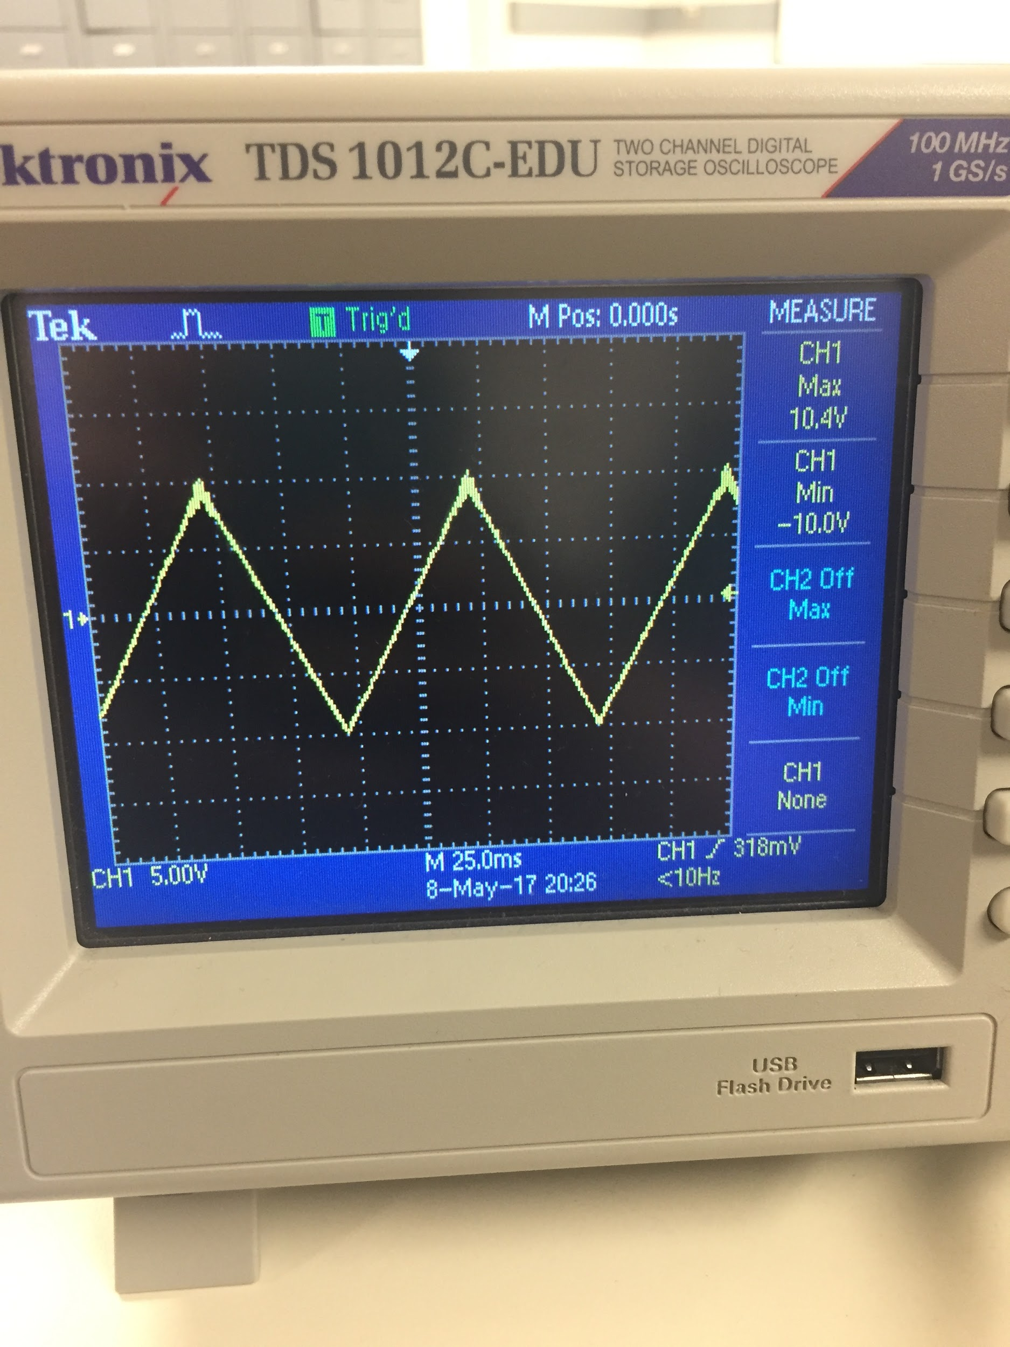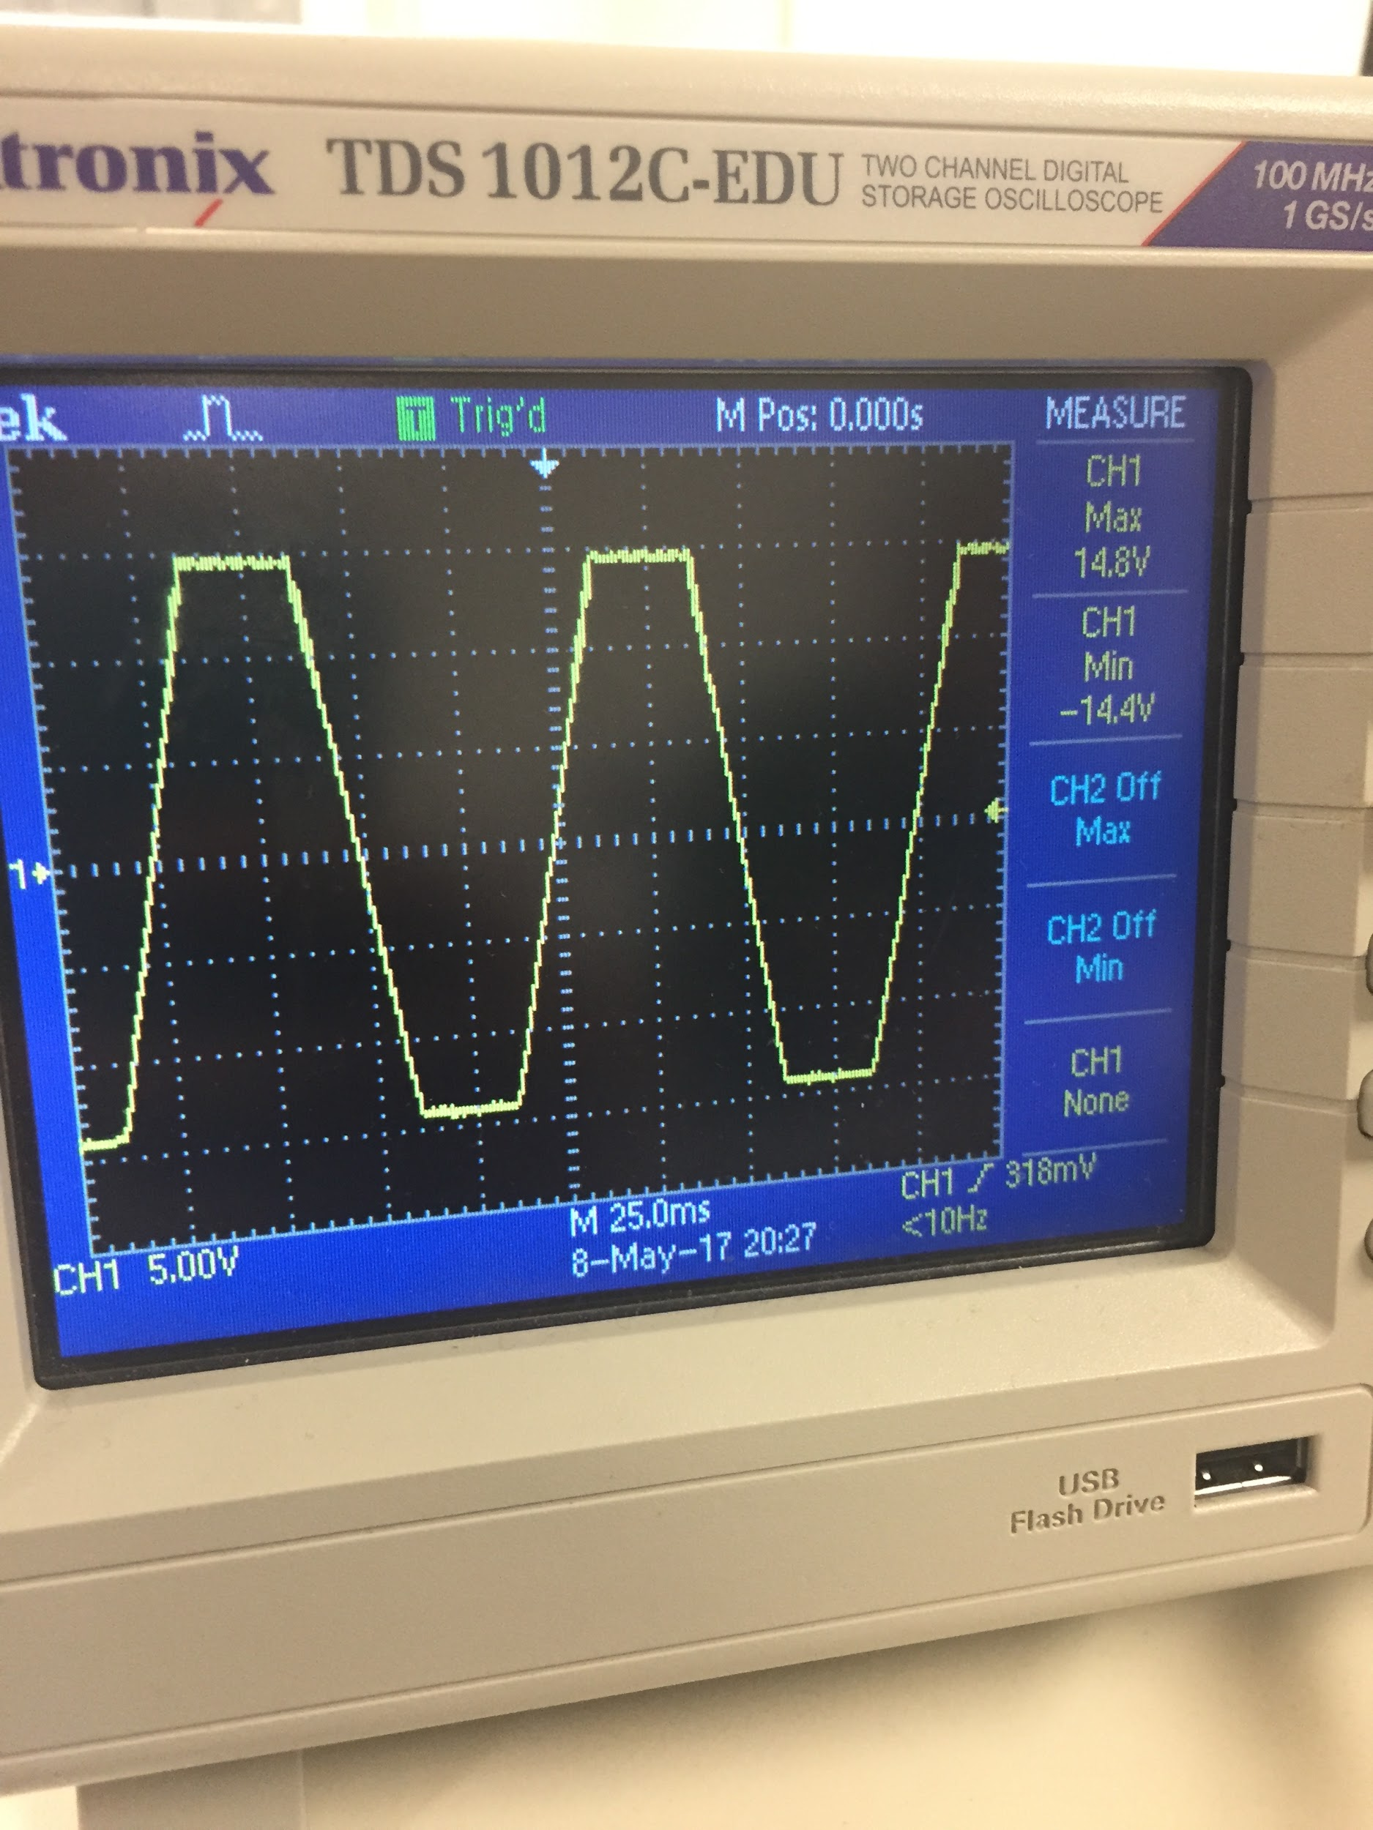

The figures below to shows our triangle and sine function from left to right.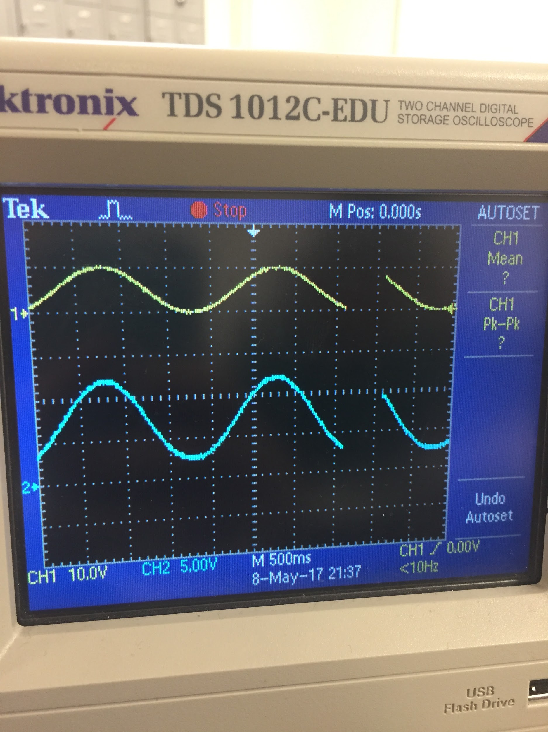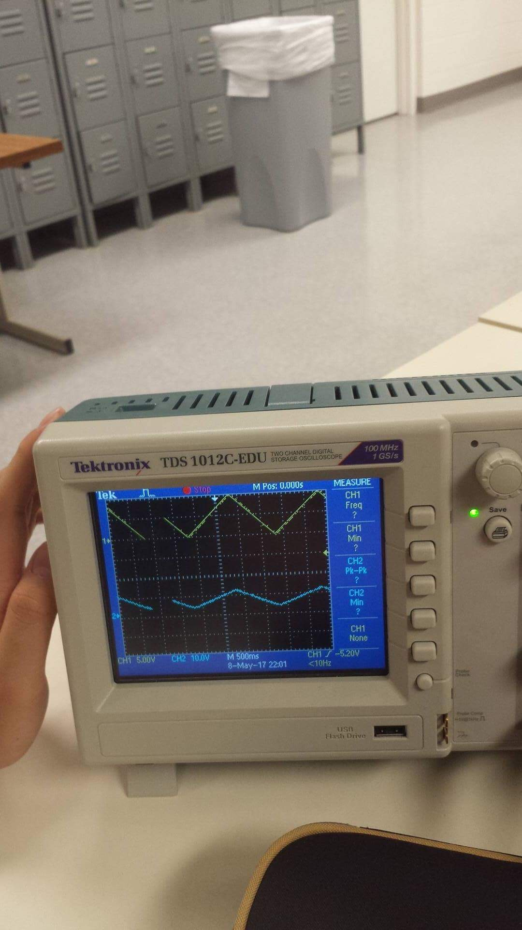

These two images above show the before and after effects of adding a capacitor in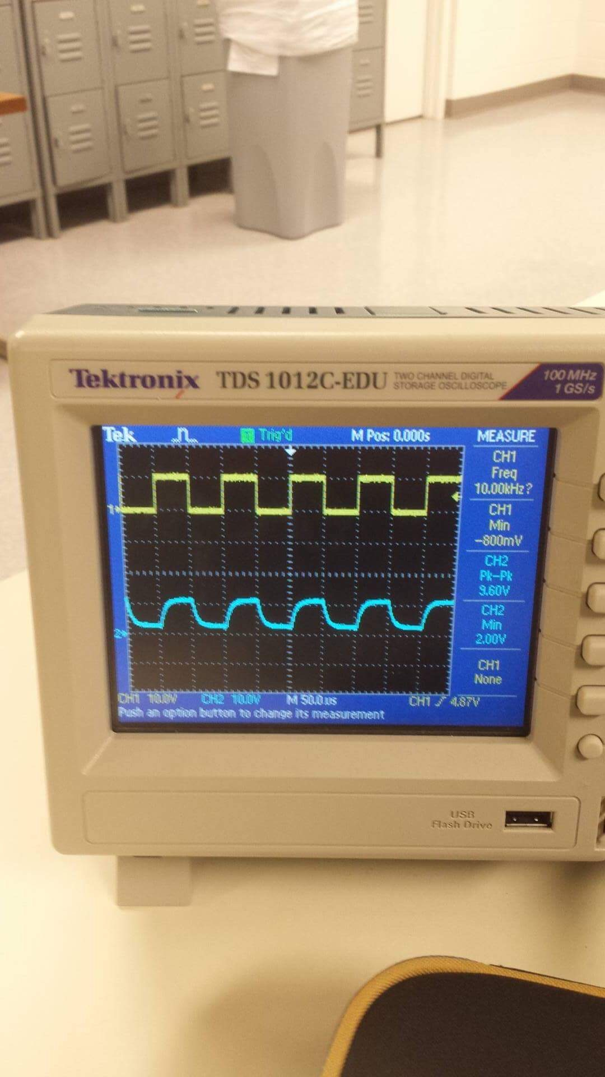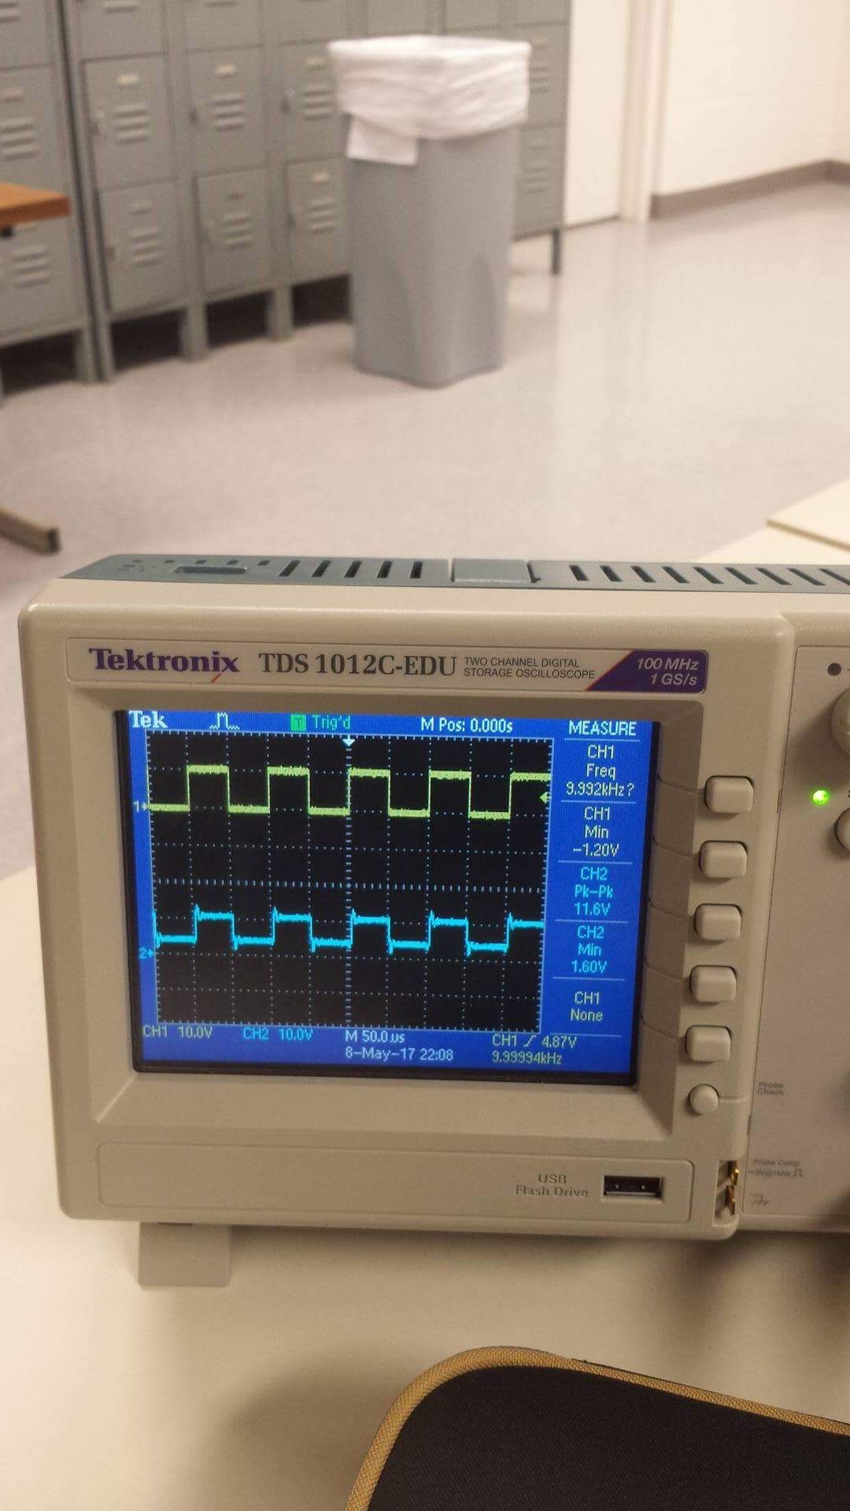

These two images below the value of the dark current.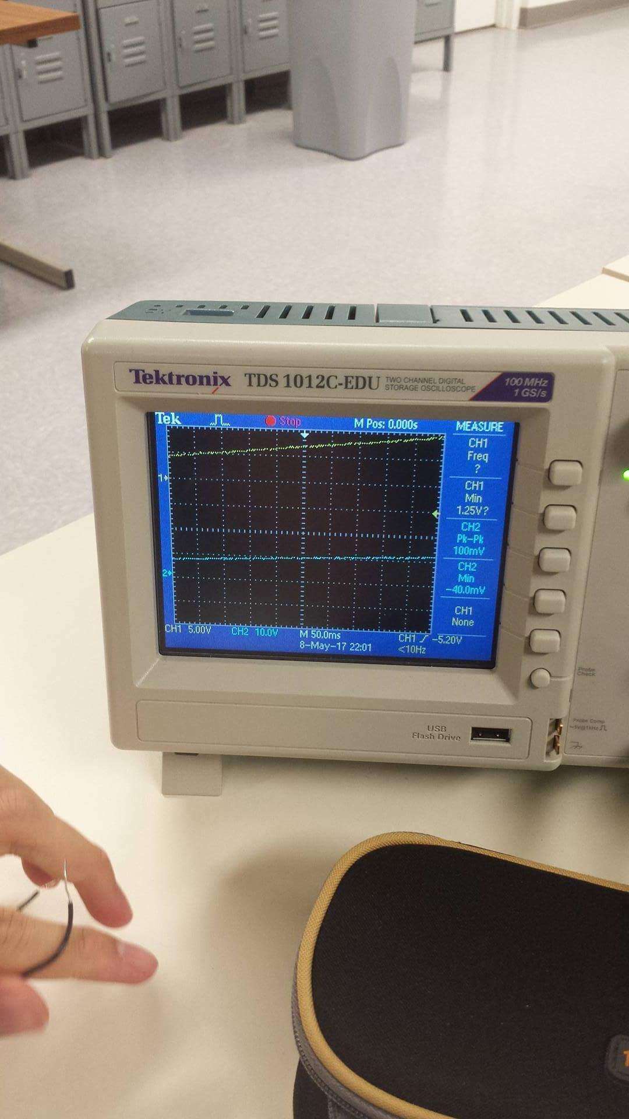

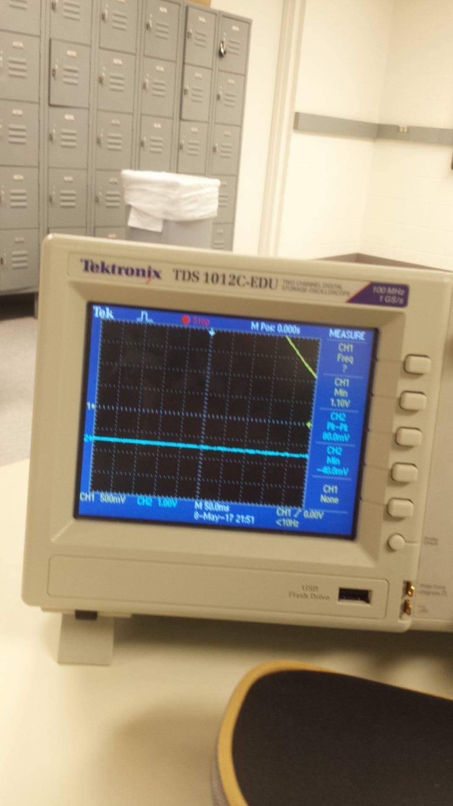

**Analysis**

During our prelab analysis, we predict the value of Av to be -10 if the input voltage is ±1V. If the input voltage is ±3V, we predict the value of Av to be -5. During the lab session, when the input voltage was switched to ±1V, the results of Av is approximately -10. Moreover, when the input voltage is changed to ±3V, we observed the gain (Av) to be at around -5 which are all in agreement with our prelab analysis. This shows that the frequency has no effect on the values of Av and the maximum output voltage for Op-Amp is ±15V. During the experiment, the clipping at the output of the Op-Amp occurs because the output of the Op-Amp is much less than the supply voltage. Furthermore, for the LED driver circuit, it converts the input voltage to a specific current output. Specifically, in LED circuit design, on the positive sign of the Op-Amp, it is connected to the input voltage. By applying virtual short, it becomes the same voltage as the negative sign of the Op-Amp. By connecting the negative side of the Op-Amp to the resistor that is connected to the ground, we effectively can control the current flowing through the resistor via changing the Vin. On the other hand, for the Photodetector circuit, it outputs a specific current as it receives light energy from the LED. Then, it is converted for voltage measurement using an Op-Amp. With regards to LED, it is noted that the LED emits light as signal for the Photodetector. Specifically, the Photodetector detects the photon and then converted into current that is observed by O-scope. Changing the input signal of the LED driver circuit would result in different amounts of light being picked up by the Photodetector. In another word, the intensity of the input signal is proportional to the current of the Photodetector. With regards to dark current, dark current is the value of the current obtained when there is no light or photons enter in the photodetector. This value is obtained by covering the photodetector with a pencil cap. Finally, we connect the capacitor in parallel with with the 1M ohm resistor, and we found out that the square function became a lot smoother. The purpose is to correct the output waveform from curved to squared.

**Conclusion**

After this lab, we were able to learn how the LED driver and Photodetector works. We also learned how to wire and utilize the LF 411 Op-Amp. This Op-Amp was a key part of this lab which enabled us to power the LED driver. The Op-Amp is an integrated circuit that helped us build this Optical data link. Another important concept was that for the 3V as our input, the graph clips and it doesn’t reach 20 V because the voltage is capped at 15 V. Conclusively, this experiment can be considered a success because we were able to create this data link and analyze the data and learn how the LED driver and Photodetector work together.